Problem Statement
The goal is to turn raw mobile-store feedback into a weekly pulse your team can scan in minutes: what users care about, what they actually said, and what to do next. Reviews are already public; your job is to aggregate, theme, summarize, and deliver that insight through familiar surfaces—Google Docs for the written pulse and Gmail for a draft you can send yourself—without handling credentials or REST wiring yourself.
End-to-end flow (what “done” looks like):
- Pull recent App Store and Play Store reviews for your product (within the rules below).
- Cluster them into a small set of themes and distill a one-page weekly note.
- Put that note where stakeholders can read it (Google Docs).
- Create a draft email to yourself (or an alias) that contains or links to that pulse (Gmail).

Deliverables
Weekly one-page pulse must include:
- Top themes (what people are talking about most)
- Real user quotes (verbatim snippets from reviews, no invented wording)
- Three action ideas (concrete next steps grounded in the themes)
Finally: send yourself a draft email containing this weekly note (or a clear pointer to it).

Who This Helps
Audience | Why
Product / Growth | Prioritize fixes and improvements from real signals
Support | Align messaging with what users are actually saying
Leadership | One-page health check without drowning in raw reviews

What You Must Build
- Import reviews from roughly the last 8–12 weeks (fields such as rating, title, text, date—whatever your export provides).
- Group reviews into at most 5 themes (examples: onboarding, KYC, payments, statements, withdrawals—pick what fits your product).
- Generate a weekly one-page note with:
  - Top 3 themes (subset of your themes as appropriate)
  - 3 user quotes
  - 3 action ideas
- Draft an email with the note to yourself or an alias.

Integrations: Google Docs & Gmail via MCP
Use MCP (Model Context Protocol) servers for Google Docs and Gmail—for example, creating or updating the pulse document and creating the draft message—rather than integrating Google APIs directly (no bespoke OAuth client + REST client code as the primary integration path). MCP servers expose tools your agent or app can call; lean on that pattern so Docs and Gmail stay consistent with the course tooling and avoid duplicating auth and HTTP plumbing.
(Choose MCP servers or connectors your environment provides for Docs and Gmail; the requirement is MCP-first, not “call Google APIs manually.”)

Key Constraints
- Reviews: Use public review exports only—no scraping behind store logins or ToS-violating automation.
- Themes: Maximum 5 themes for clustering; the written pulse highlights the top 3.
- Length: Keep the note scannable and ≤250 words where applicable.
- Privacy: Do not include PII—no usernames, emails, device IDs, or other identifiable reviewer data in any artifact (quotes should be anonymous / stripped as needed).

Diagram Flow
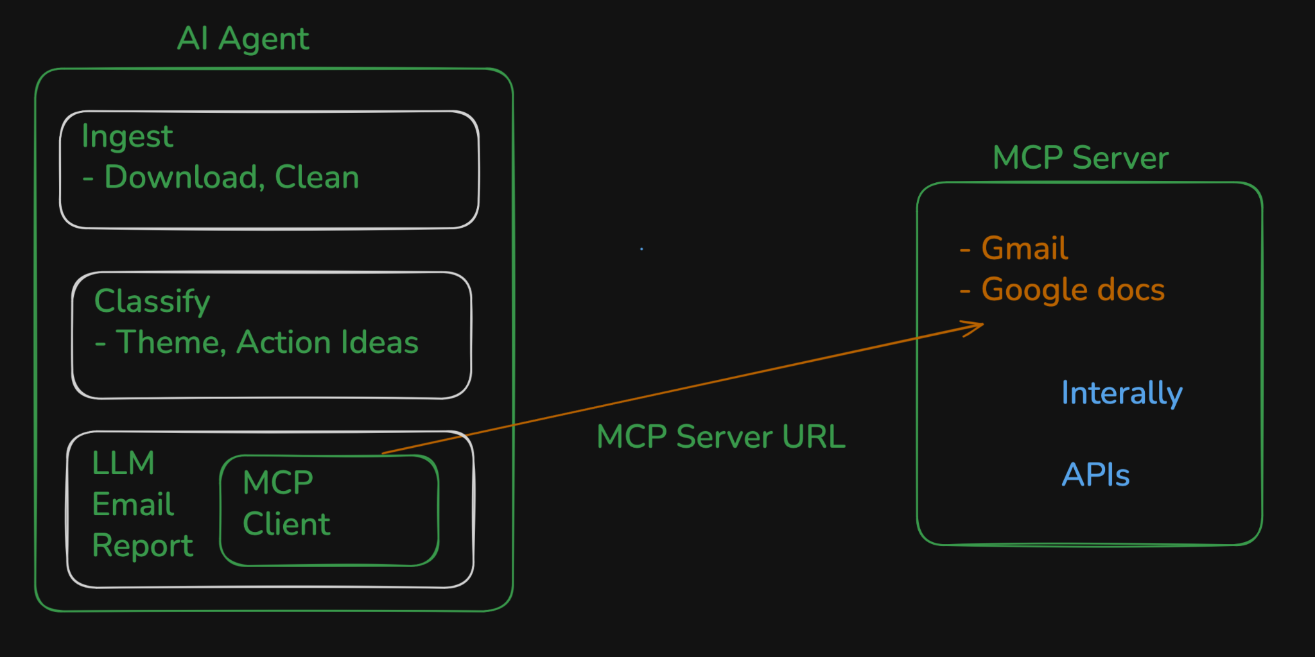

Prompts
- Generate problemStatement.md which stores the necessary context of this project @docs/problemStatement.txt
- Generate detailed architecture.md from @docs/problemStatement.md
- Generate a phase-wise implementation-plan.md using @docs/architecture.md and @docs/problemStatement.md
- Generate edge-case.md for handling necessary edge cases and corner scenarios
- Implement phase0 as per the @docs/implementation-plan.md
- Implement phase1 as per the @docs/implementation-plan.md
- Implement phase2 as per the @docs/implementation-plan.md
- Have we downloaded last 12 weeks of reviews
- We need to download actual reviews from playstore and app store
- Run the code changes and then download the reviews
- 1. Reviews which have less than 8 words are not required
2. reviews which have emoji are not required
3. Reviews in hindi language are not required
Update the @docs/implementation-plan.md in phase2 so that above reviews we clean and then update the code of phase2
- Run the above part so that we have the normalized reviews
- Based on the @output/normalized_reviews.json think on analyze Strategy in phase3 and update the @docs/implementation-plan.md
- Implement phase4 as per the @docs/implementation-plan.md
- Reviewids in topThemes are not required so we can remove that
- Implement phase5 as per the @docs/implementation-plan.md
These the are limits
Model - llama-3.3-70b-versatile
request per minute - 30
tokens per minute - 1K
Request per day - 12K
tokens per day - 100K
- Run phase5 with Groq, I have added API key as well
- MCP SERVER URL
github of MCP server - <Github MCP>
Check the functionalities of MCP server and then update phase 6 the @docs/implementation-plan.md

EXTRA
- Scheduler → Github (SAME scheduler RAG)
- Frontend → Dashboard (Stitch)

MCP server steps
- https://console.cloud.google.com/
- Enable APIs - Google Docs API and Gmail API
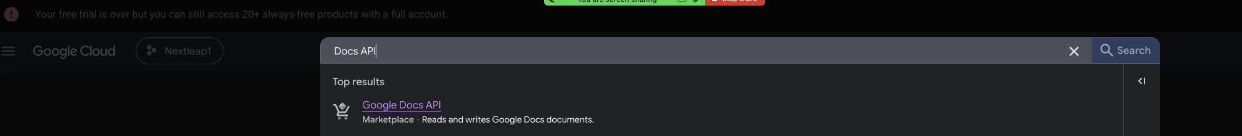
- Credentials
  - Configure Content
  - Create Oauth client
    - Generate JSON
  - Audience → Add test user → Add your email

Prompts for MCP server
CHATGPT
Generate an problemStatement.md which I can give to cursor for building MCP server -

We need to build an MCP server for supporting our AI agent so that it can send and draft emails with GMAIL and it can append content to google doc.

Two main functionalities can be there
1. Sending email via Gmail
2. Append content to google doc

MCP server should be generic so that even other AI agents can use it.

CURSOR
- Generate an Implementation-plan.md using @problemStatement.md for Implementing MCP server
- Implement phase1-5 using the @Implementation-plan.md
- <FILE JSON which we got from above step> is added
Run the code to generate tokens.json
Deployment of MCP server
- Create an deployment-plan.md for deploying this MCP server on railway
- Implement the necessary deployment changes as per the @deployment-plan.md
- Push the changes to github
- Deploy on railway
- Checked and verified that deployment is successful

Download Reviews
Downloading Reviews
How to get real App Store and Play Store reviews into data/exports/.
Quick start
- Add your app identifiers to .env:
PRODUCT_NAME=Your App Name
APP_STORE_ID=1234567890 # numeric id from App Store URL
PLAY_STORE_PACKAGE=com.company.app
DOWNLOAD_WEEKS=12 # 8–12 allowed
APP_STORE_COUNTRY=us # optional storefront
EXPORTS_DIR=./data/exports

- Run:
npm run download:reviews

- Verify ingest:
npm run pulse

Finding your app identifiers
Store | Where to find it | Example
App Store | URL https://apps.apple.com/us/app/name/id**1234567890** | APP_STORE_ID=1234567890
Play Store | URL https://play.google.com/store/apps/details?id=**com.company.app** | PLAY_STORE_PACKAGE=com.company.app
How each store is fetched
App Store — Apple iTunes RSS (recommended)
- Official public feed — no API key or login
- Endpoint: itunes.apple.com/.../rss/customerreviews/...
- Up to ~500 recent reviews per country (10 pages × 50)
- Output: data/exports/app_store_reviews.csv
If you need full history for an app you own, export from App Store Connect instead and replace the CSV manually.
Play Store — public listing scraper
- Uses google-play-scraper against the public Play Store listing
- No Play Console login required
- Paginates until reviews are older than DOWNLOAD_WEEKS
- Reviewer names are not written to the CSV (privacy)
- Output: data/exports/play_store_reviews.csv
If you are the publisher, the most complete compliant source is a CSV export from Google Play Console (User feedback → Reviews → Export). You can drop that file into data/exports/ and skip the Play download.
Manual console export (alternative)
Store | Steps
App Store Connect | Apps → your app → Ratings and Reviews → export
Play Console | Download reports → Reviews, or in-app review export
Name files with app_store and play_store in the filename so ingest auto-detects them.
Limits
Limit | Detail
App Store RSS cap | ~500 reviews per APP_STORE_COUNTRY
Date window | DOWNLOAD_WEEKS filters to last 8–12 weeks after download
Rate limiting | Built-in delays between paginated requests
Troubleshooting
Issue | Fix
APP_STORE_ID is required | Set numeric id in .env
App Store RSS 404 | Wrong id or country code
Play Store 0 reviews | Wrong package name or app has no public reviews
Fewer than expected | RSS cap, or sparse review volume in the window

